Besides face-to-face meeting, we also use Skype for Business and the company’s emails to communicate with the client and discuss with team members.

Our client: Mr. To Hoa Duy Man (RBVH)

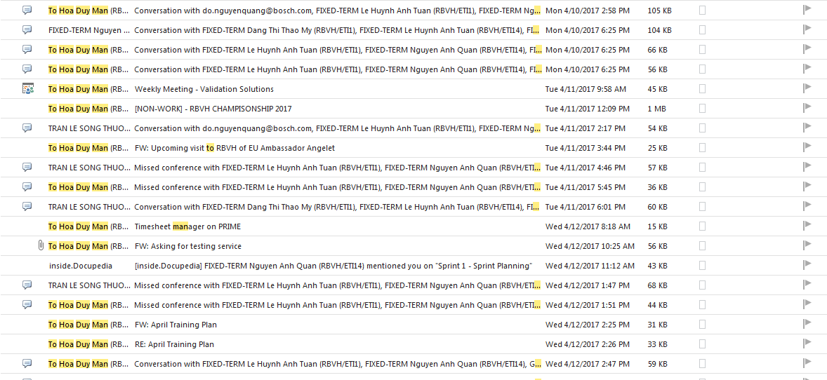

Figure 1 some conversations with the client.

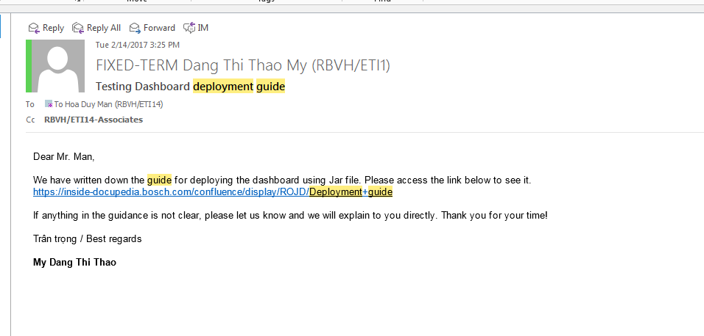

Figure 2 Email to inform deployment.

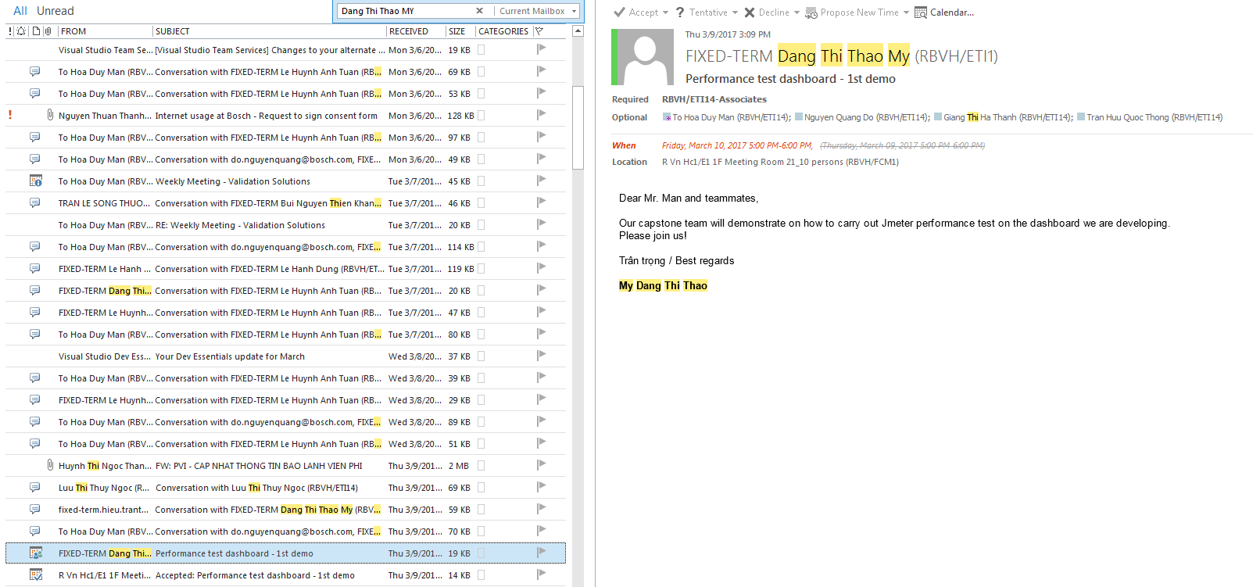

Figure 3 Email to invite the end users and the client to join a demo meeting.

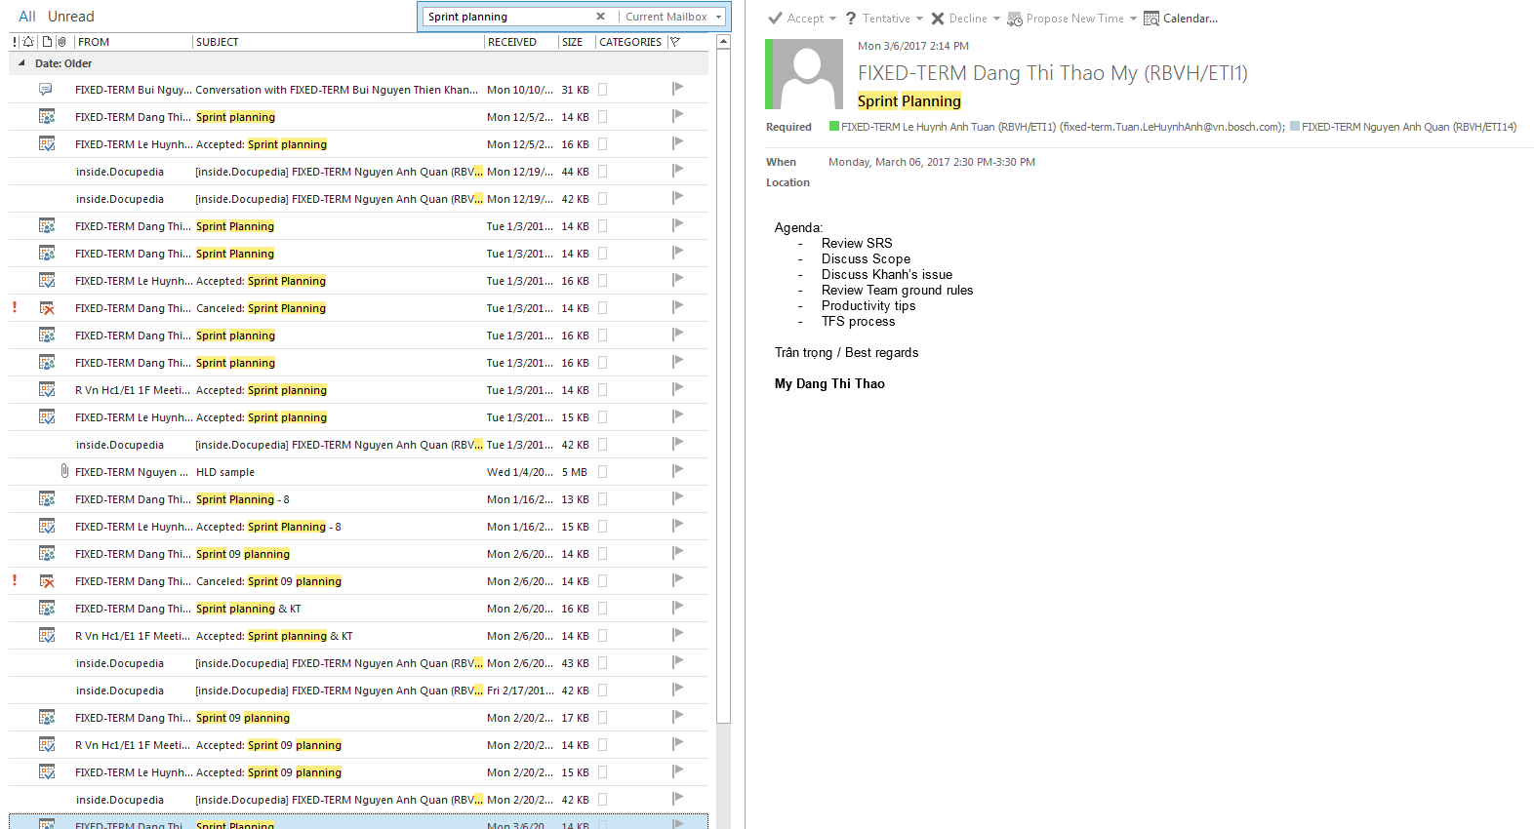

Figure 4 Schedule sprint planning.

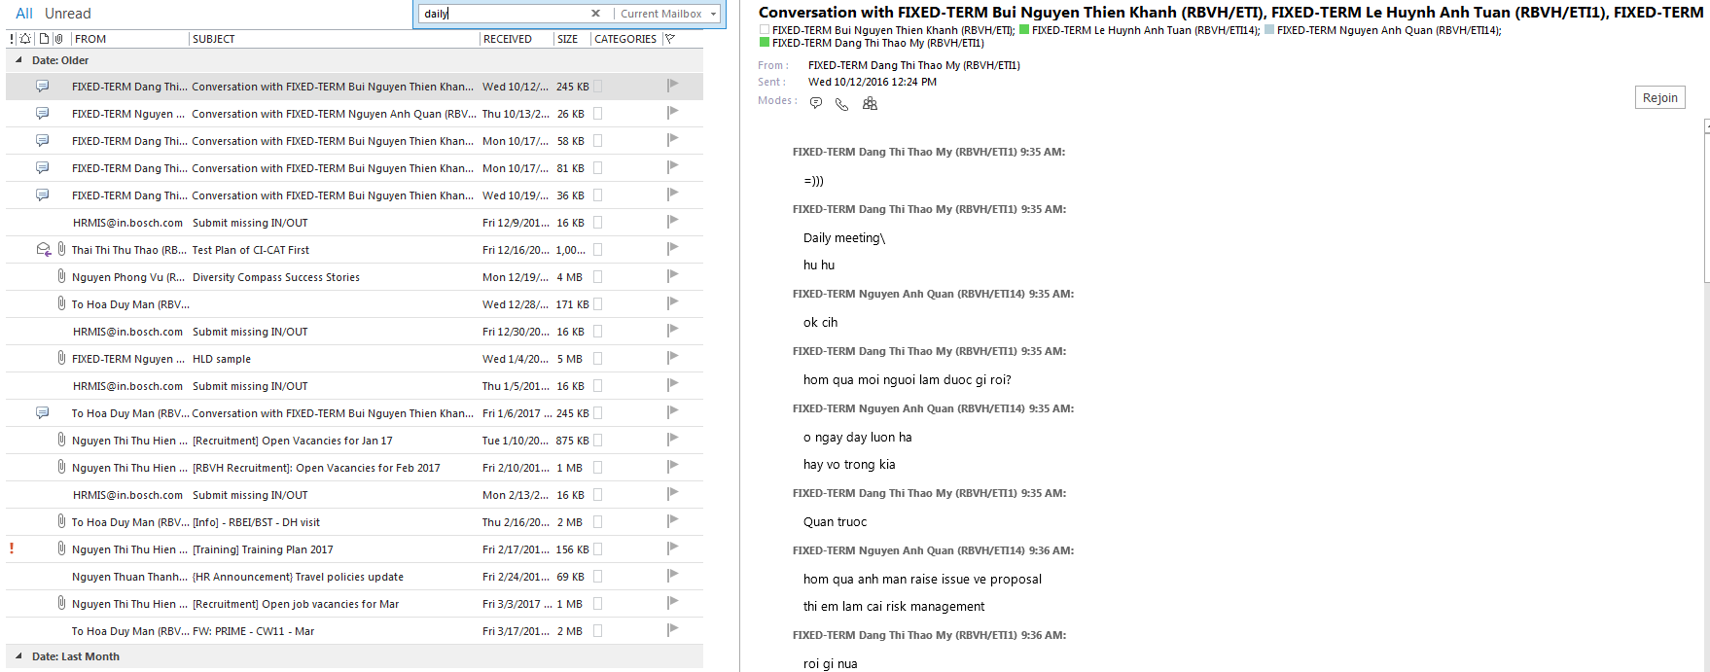

Figure 5 When all the meeting are busy, we use Skype meeting or conversation.

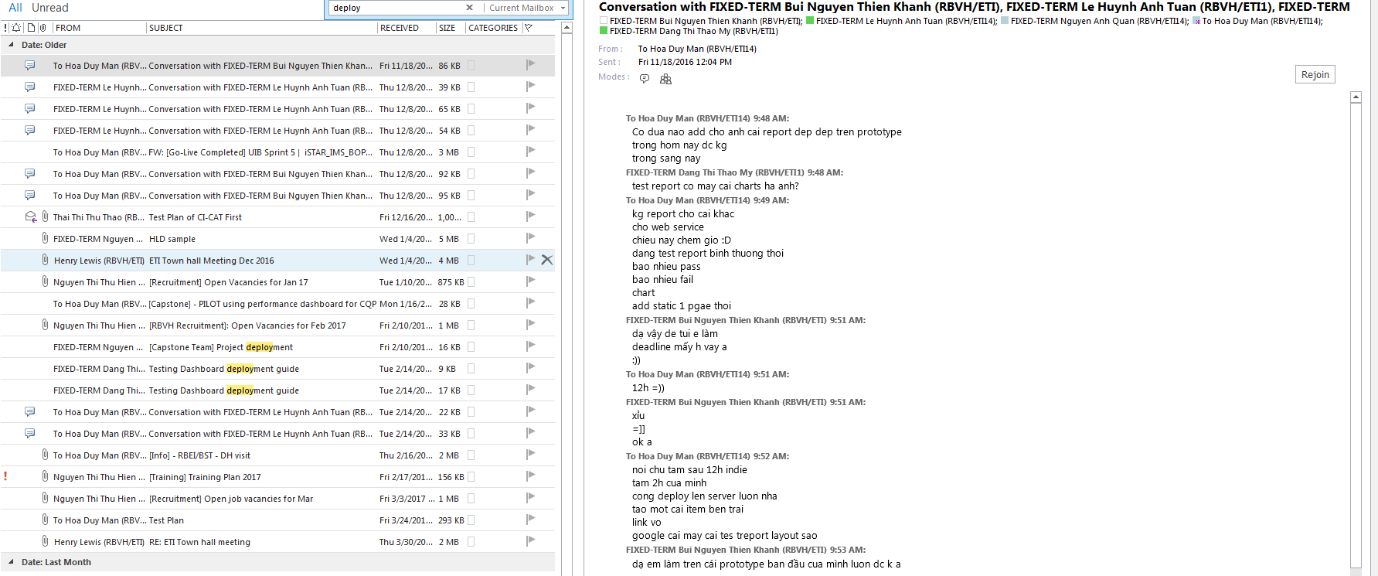

Figure 6 A conversation with the client